

**UNIVERSITY OF ASIA PACIFIC**

**Department of Computer Science & Engineering**

**Course Title –**  Computer Networks Lab

**Course Code –** CSE 320

**Experiment No. –** 05

**Experiment name –** Instant Performance Lab report with packet tracer file.

**Submitted by: Submitted To:**

Shawan Das. Dr.A S M Touhidul Hasan

ID –19101020 Assistant Professor,

Section –A1 University of Asia Pacific

**Date of Performance –**  06-02-2022

**Date of Submission –**  12-02-2022

**Problem Statement :** Design connection between West zone [R0,R1,R2] & East zone[R4,R4,R5].

**Apparatus :**

* PC / Computer
* Switch (2960)
* Server
* PT-Router

**Network Design :** Let’s say we have 2 zones[East Zone & West Zone] Both Zones have their dedicated DNS server [West Zone , East Zone]. Each zone’s devices will use their dedicated DNS server. Which means West Zone devices will use Server- West Zone and East Zone devices will use Server- East Zone. The servers will be S1,S2,S3 & S4 (connected to Router-5, Network-192.168.26.0).

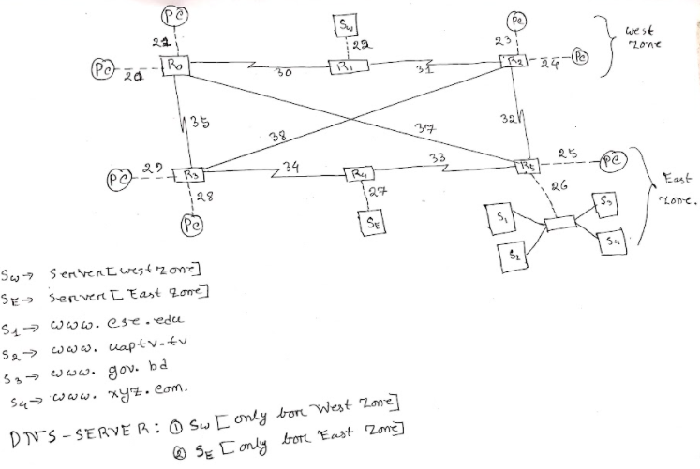

Now in Cisco Packet tracer we will implement our design. First we will put the necessary Switch, PC, Server. Then we will connect them. To connect our device, we will always remember that for the same type of device we need **copper cross-over** connection and for different type devices, we need to connect **copper straight-through** connection. So PC to Switch and Server to Switch connection will be straight through connection and Switch to Switch connection will be cross-over connection. Then we will note down the IP addresses of our connected PC, Server & Networks. Then we will rename the server and note down their IP addresses.

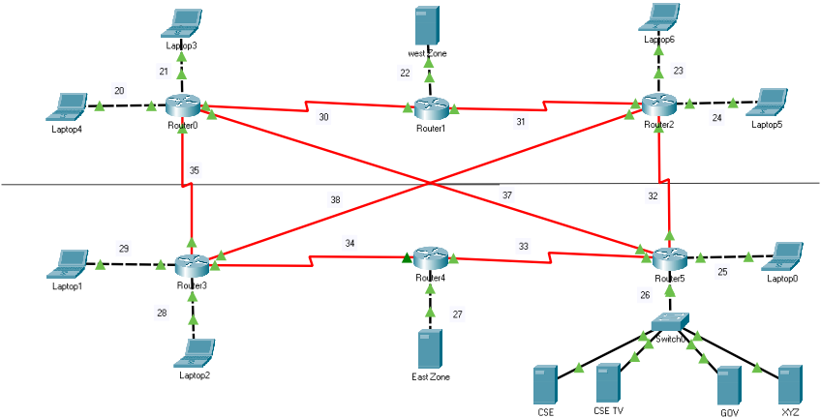

Now we will note down necessary information IP-addresses and use it for network setup.

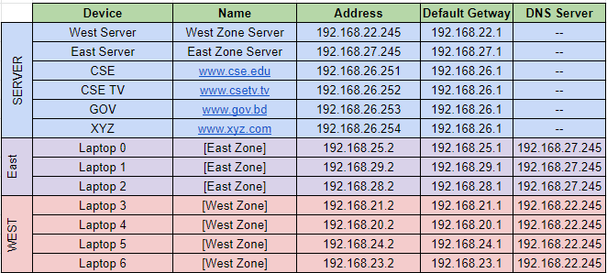

Now we will configure routers according to the note in Cisco. Then we will Configure Servers. Add the address in the router according to their port, network & IPv4. And don’t forget to activate the port of routers.

**Server Setup :**

* Select server[East, West, CSE, CSE TV, GOV, XYZ].
* Go to Desktop > IP Configuration.
* Insert IPv4 address and Default Getway according to the note.

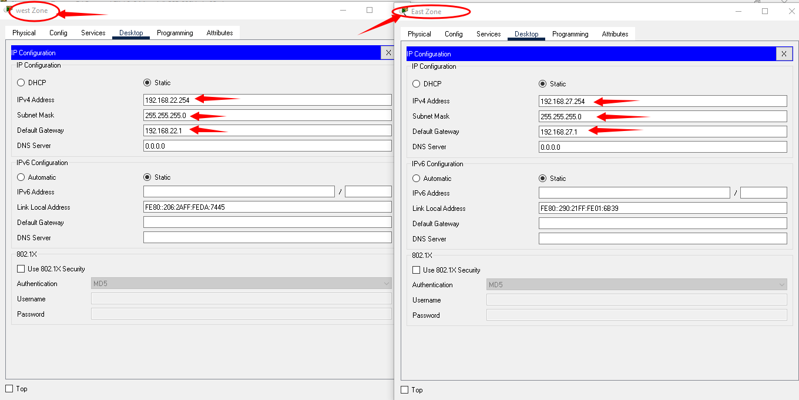

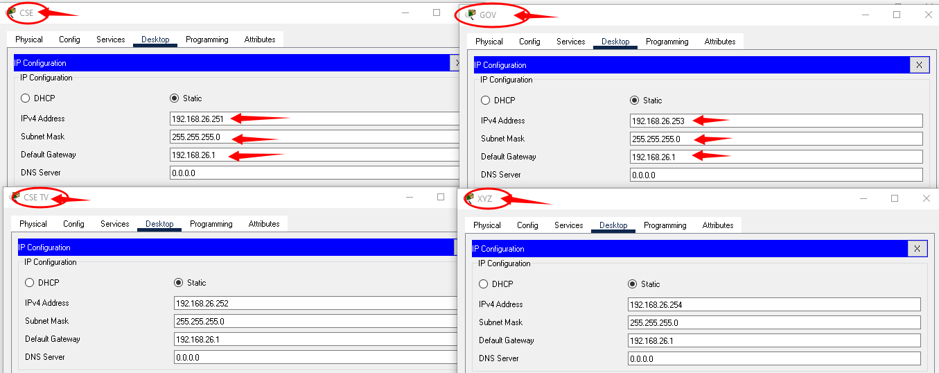

And we are done for server setup.

**PC/Laptop Configuration :**

Now we will configure our PC according to our excel note [page:2-Table-1].

* Select a PC to configure.
* Desktop > IP Configuration.
* Inset IPv4 address, default getway, DNS server according to the note.
* We will use the west server(192.186.22.254) for the west zone PC and east server(192.168.27.254) for the east zone.

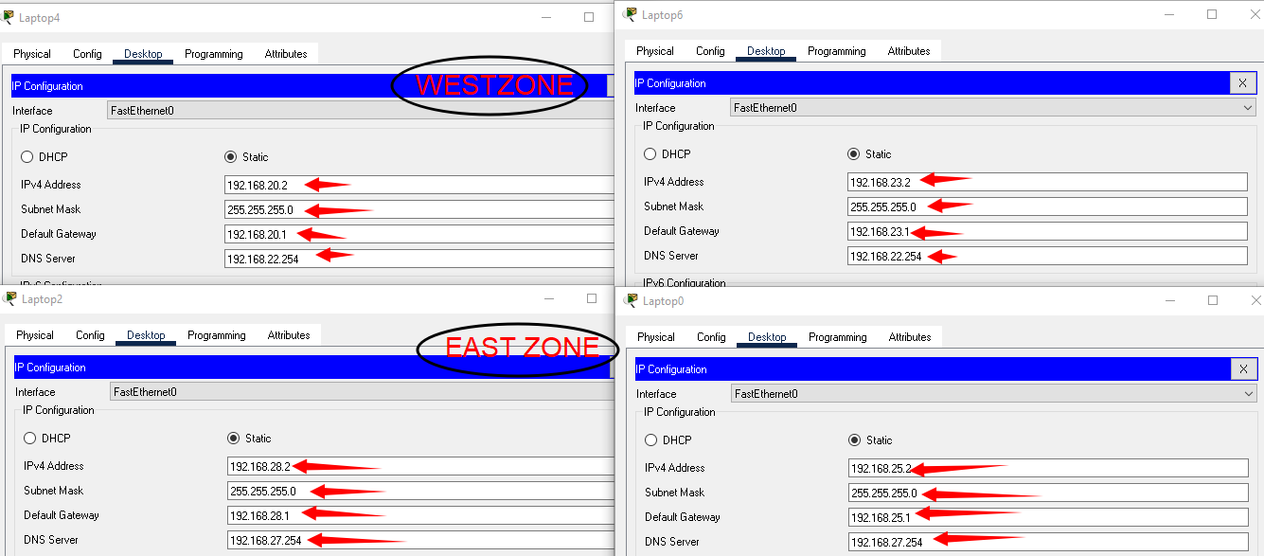

**DNS Configuration :**

* Select west server & east server. Then Services > DNS
* ON the DNS. Then enter the Name and addresses of CSE, CSE TV, GOV, XYZ according to the table.
* Then click ADD button and you can see the added Name below.

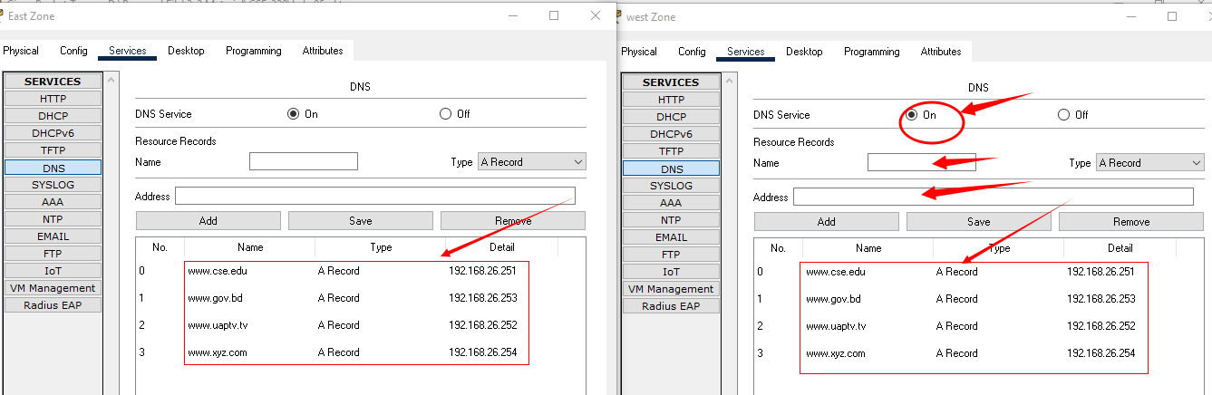

**RIP VERSION-2 Configuration :**

Now we have to establish RIP version-2 configuration to establish a successful communicative connection between all used routers.

* Select a router. Then CLI there comes a box where we need to write some code.
* Follow the steps:

enable

conf t

router rip

version 2

no auto summary

network 192.168.20.0[for example]

network 192.168.21.0[for example]

end

* Do this work for all routers according to the table below:

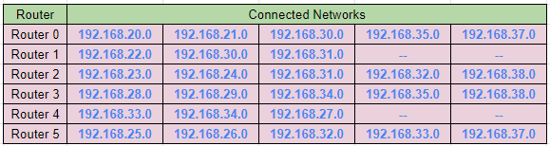

* After configuring all routers, we can check using [show ip route] to confirm that all networks are connected.

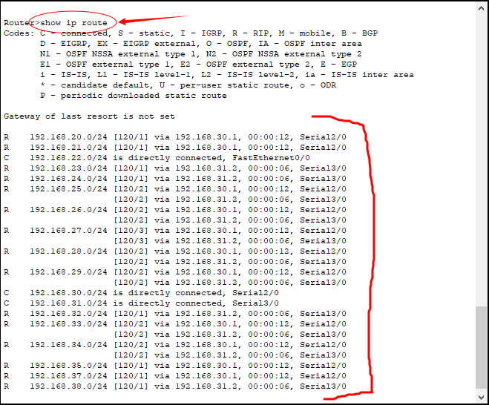

if everything is ok, we are good to go for web search.

Now we just need to select any PC and search for the addresses [www.cse.edu](http://www.cse.edu) , [www.uaptv.tv](http://www.csetv.tv) , [www.gov.bd](http://www.gov.bd) , [www.xyz.com](http://www.xyz.com) if it shows the web page, then our objective is successful.

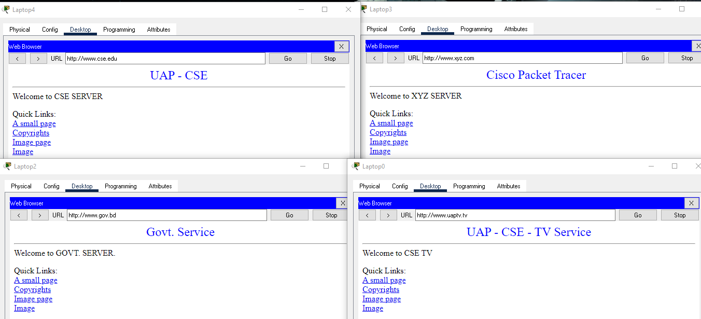

**Final Design :**

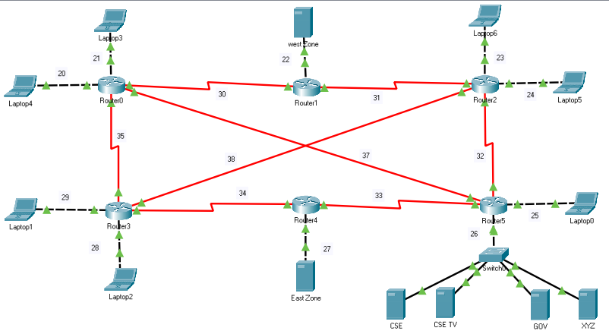

**Learning :**

In this experiment, we learned about RIP version-2 configuration and managed multiple DNS servers.

**Discussion:**

It may take some time to establish a connection. Please wait until the node of the connection turns green. Be careful with cross-over & Straight through connection. Same Type Device- Cross-over, different type device: Straight - Through connection. Be careful when you are adding networks in RIP configuration. You can also use [show ip route] before doing rip config. It will show you which networks are connected with the router and it will be easy for you to know which network you should add for RIP. Send packages from PC to PC or use Command prompt to check the connection between devices. If there were any kind of error, check the IPV4 addresses. Try to use switch-2960 with 24-ports.